Ntimer Setup

## Requirements:

* Ntimer
* Ntimer Power Supply 9V
* Arduino UNO
* USB-A to USB-B Cable
* USB-A to Micro-USB B Cable
* 1kOhm Resistor
* 3x Male to Male Wire, 1x Male to Female Wire (plug 1kOhm resistor into female end)
* Windows PC with software installed:
  + [Arduino IDE](https://www.arduino.cc/en/Main/Software)
  + [JRE - Flip Installer - 3.4.7.112](https://www.microchip.com/Developmenttools/ProductDetails/FLIP)

# Setup Bootloaders and USB-Serial converter

## Step 1 – Loading the Arduino Bootloaders

We need to load the Arduino bootloaders into our two microcontrollers. Follow these steps:

1. Connect USB from Computer to Arduino UNO
2. Plug in 9V power supply into Ntimer
3. Open the file Atmega_Board_Programmer\Atmega_Board_Programmer.ino in the Arduino IDE
4. Chose as board Arduino UNO
5. Set the right serial port of your USB connection
6. Open the Serial terminal and change it to 115200 Baud (see Appendix 1)
7. Compile and upload the software
8. Connect the ICSP Arduino Uno pins 1, 3, 4 and 6 of the to the ICSP USB of Ntimer with a 1kOhm resistor in every connecting wire except for pin 6 (Ground). Please do not connect pin 2 of ICSP. See Appendix 3.
9. Connect Arduino Uno Pin 10 to Reset Pin 5 on Ntimer ICSP USB with 1kOhm resistor in connecting wire.
10. The software on the arduino will detect wich IC is connected and it will write the bootloader onto the chip. If you don’t see a message on the serial terminal reboot the Ardino.
11. When board programmer recognizes the microcontroller for programming Pressend “G” the bootloader in the Target device. This programs the ATMEGA16U2 with the Arduino Bootloader. See Appendix 2.
12. Repeat steps 8-11 but change from ICSP USB on Ntimer to ICSP to program the ATMEGA2560 with the Arduino Bootloader.
13. You can now disconnect the ICSP wires from Arduino and Ntimer, bootloader flashing is done. Disconnect the Arduino UNO from USB.

## Step 2 – Flashing the USB-Serial Converter

We need to make the ATmega16U2 our USB-Serial converter. Follow these steps:

1. Connect the Ntimer via micro USB.
2. Open the Flip software.
3. Click the *Select Target Device* button  and select “ATMEGA16U2”.
4. Click the *Select Communication Medium* button  and select USB. After this press Open.
   1. If you get the error message AtLibUsbDfu.dll not found open your Windows Device manager. It will show an unknown device. Right click it and select “install driver”. The driver location is “C:\Program Files(x86)\Atmel\Flip 3.4.7\usb”. It will install the driver and your ATmega16U2 will now show. 
   2. Close the error message and restart flip after installing the driver.
5. Select File -> Load Hex File and choose “Arduino USB-Serial/Arduino-usbserial-mega.hex”
6. Click on Run button in the bottom left part of the software. If will say “Verify Pass” if everything went well.
7. Please close Flip.

Congratulations, you turned Ntimer into an Arduino ATMega.

# Loading the Ntimer Sketch

## Step 3 – Verify Function

Before we start verify that you can talk to the Ntimer by letting LED13 blink through loading an Arduino project.

1. Reboot Ntimer by unplugging power for 5 seconds and plug it back in.
2. Open the “Blinking/blinking.ino” sketch.
3. Set device to “Arduino/Genuino Mega or Mega 2560”
4. Make sure the right COM port is selected for your connected cable.
5. Compile and upload the sketch.
6. Now on the Ntimer PCB D2 is blinking.

Congratulations, everything went well and you have a working Arduino Mega Ntimer.

## Step 4 – Loading the Ntimer Sketch

Now it is time to load the ntimer sketch into the Ntimer.

## Step 3 – ???

1. The SD-Card must be formatted in FAT32.
2. Format the card
3. Put inside the file called LOGIN.TXT with the following lines

USERNAME

PASSWORD

SERVER NAME

# 

# Appendix

## Appendix 1

Com Terminal with Baud rate set correctly to 115200 Baud:

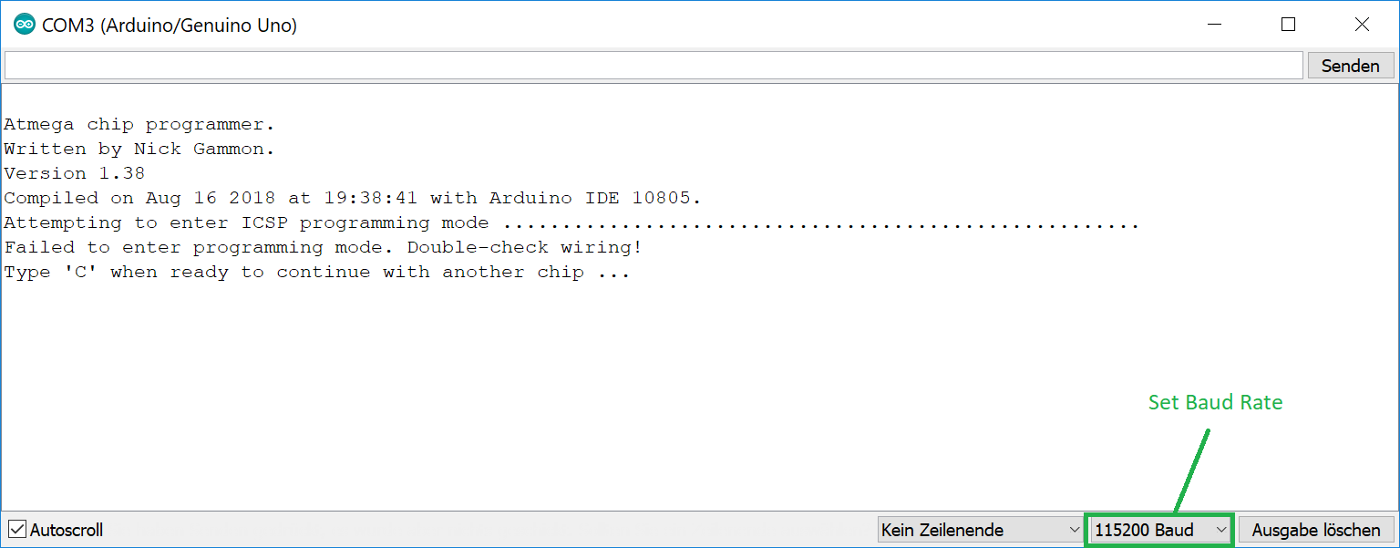

## Appendix 2

Step 11 - Microcontroller recognized, enter G on top and press “send”:

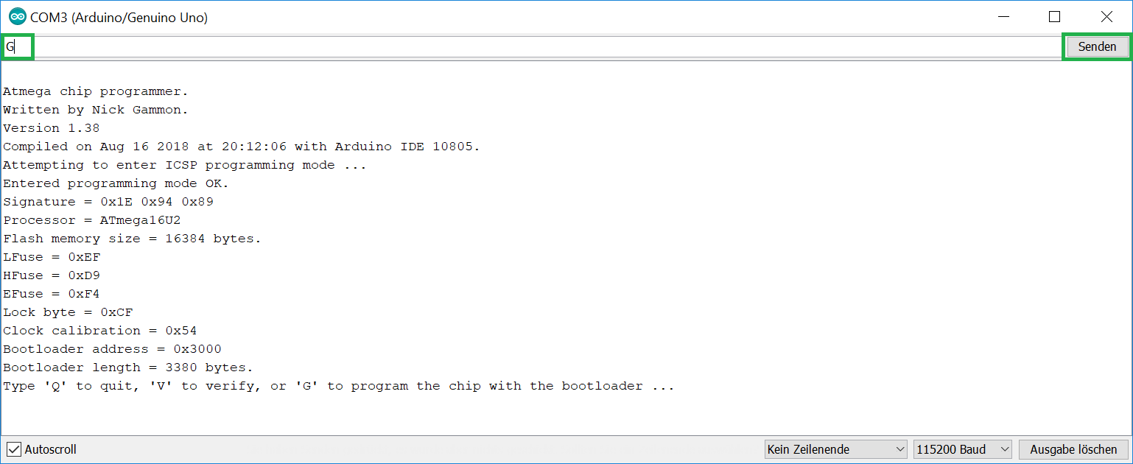

Step 11 - Microcontroller successfully programmed:

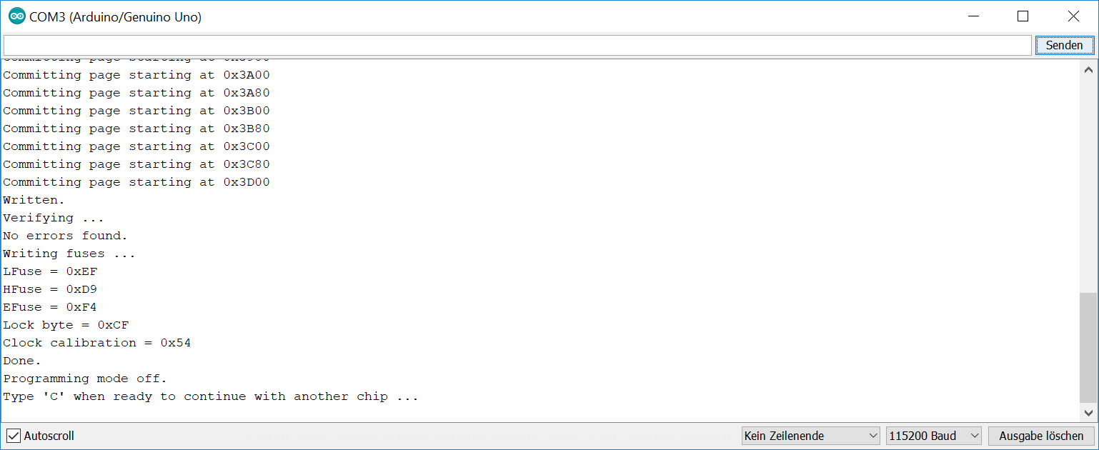

## Appendix 3

Arduino UNO Pins

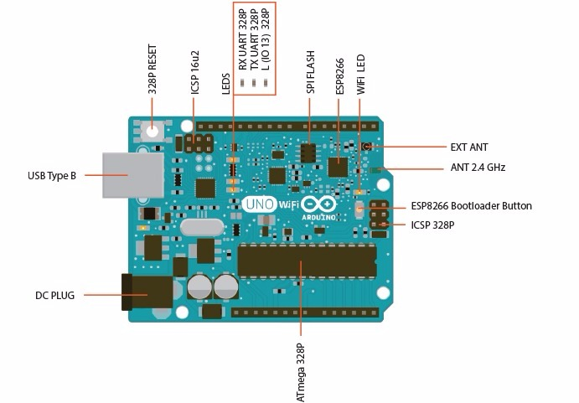

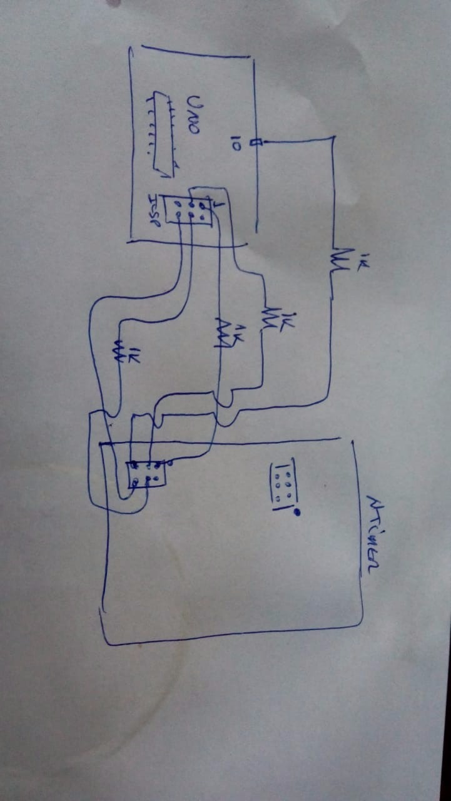

## Appendix 4

Flip successfully connected.

